**VIDEO GAME SALES**



GEETANJALI SACHDEV

BRIEF ABOUT VIDEO GAMES

A **video game** is an [electronic game](https://en.wikipedia.org/wiki/Electronic_game) that involves interaction with a [user interface](https://en.wikipedia.org/wiki/User_interface) to generate visual feedback on a two- or three-dimensional [video](https://en.wikipedia.org/wiki/Video) [display device](https://en.wikipedia.org/wiki/Display_device) such as a [touchscreen](https://en.wikipedia.org/wiki/Touchscreen), [virtual reality headset](https://en.wikipedia.org/wiki/Virtual_reality_headset) or [monitor](https://en.wikipedia.org/wiki/Computer_monitor)/[TV set](https://en.wikipedia.org/wiki/TV_set). Since the 1980s, video games have become an increasingly important part of the [entertainment industry](https://en.wikipedia.org/wiki/Entertainment_industry), and whether [they are also a form of art](https://en.wikipedia.org/wiki/Video_games_as_an_art_form) is a matter of dispute.

The electronic systems used to play video games are called [platforms](https://en.wikipedia.org/wiki/Computing_platform). Video games are developed and released for one or several platforms and may not be available on others. Specialized platforms such as [arcade games](https://en.wikipedia.org/wiki/Arcade_game), which present the game in a large, typically [coin-operated](https://en.wikipedia.org/wiki/Currency_detector) chassis, were common in the 1980s in [video arcades](https://en.wikipedia.org/wiki/Amusement_arcade), but declined in popularity as other, more affordable platforms became available. These include dedicated devices such as [video game consoles](https://en.wikipedia.org/wiki/Video_game_console), as well as general-purpose computers like a [laptop](https://en.wikipedia.org/wiki/Laptop), [desktop](https://en.wikipedia.org/wiki/Desktop_computer) or [handheld computing devices](https://en.wikipedia.org/wiki/Mobile_device).

The [input device](https://en.wikipedia.org/wiki/Input_device) used for games, the [game controller](https://en.wikipedia.org/wiki/Game_controller), varies across platforms. Common controllers include [gamepads](https://en.wikipedia.org/wiki/Gamepad), [joysticks](https://en.wikipedia.org/wiki/Joystick), [mouse devices](https://en.wikipedia.org/wiki/Mouse_(computing)), [keyboards](https://en.wikipedia.org/wiki/Keyboard_(computing)), the [touchscreens](https://en.wikipedia.org/wiki/Touchscreen) of [mobile devices](https://en.wikipedia.org/wiki/Mobile_device), or even a person's body, using a [Kinect](https://en.wikipedia.org/wiki/Kinect) sensor. Players view the game on a [display device](https://en.wikipedia.org/wiki/Display_device) such as a [television](https://en.wikipedia.org/wiki/Television) or [computer monitor](https://en.wikipedia.org/wiki/Computer_monitor) or sometimes on [virtual reality](https://en.wikipedia.org/wiki/Virtual_reality) [head-mounted display](https://en.wikipedia.org/wiki/Head-mounted_display) goggles. There are often game [sound effects](https://en.wikipedia.org/wiki/Sound_effect), music and voice actor lines which come from [loudspeakers](https://en.wikipedia.org/wiki/Loudspeaker) or [headphones](https://en.wikipedia.org/wiki/Headphones). Some games in the 2000s include [haptic](https://en.wikipedia.org/wiki/Haptic_technology), vibration-creating effects, [force feedback](https://en.wikipedia.org/wiki/Haptic_technology) [peripherals](https://en.wikipedia.org/wiki/Peripheral) and [virtual reality](https://en.wikipedia.org/wiki/Virtual_reality) headsets.

Since the 2010s, the commercial importance of the [video game industry](https://en.wikipedia.org/wiki/Video_game_industry) has been increasing. The emerging Asian markets and [mobile games](https://en.wikipedia.org/wiki/Mobile_game) on [smartphones](https://en.wikipedia.org/wiki/Smartphone) in particular are driving the growth of the industry. As of 2018, video games generated sales of US$134.9 billion annually worldwide,[[1]](https://en.wikipedia.org/wiki/Video_game#cite_note-1) and were the third-largest segment in the U.S. entertainment market, behind broadcast and cable TV.

DATA SET DESCRIPTION:

Link to Data Set : <https://www.kaggle.com/xtyscut/video-games-sales-as-at-22-dec-2016csv>

This data sets contains records from year 1989-2016

**Columns in the Data Set:**

Name*(Name of the Video Game)*

Platform

Year_of_Release

Genre

Publisher

NA_Sales*(North America)*

EU_Sales*(Europe)*

JP_Sales*(JAPAN)*

Other_Sales

Global_Sales

Critic_Score

Critic_Count

User_Score

User_Count

Developer

Rating

Rating Parameters used:

**Early Childhood** - Games with the **EC** mark are geared towards children ages 3 and up.

**Everyone** - Games marked **E** are well suited for a general audience. They have minimal violence but may contain some crude language.

**Teens** - Games with the **T** mark are for older kids, ages 13 and up. These games often have violent content and can contain strong language.

**Mature** - Games marked **M** are for people 17 and older. They usually have very violent or gory content, strong language and possible nudity.

Games that have not yet been rated but have been approved will have the letters **RP** in the box for Rating Pending. An older rating that you may still find on some games is the **K-A** rating. This stands for Kids to Adults and was replaced in 1998 by the Everyone rating, but is essentially the same.

VISUALIZATION 1:

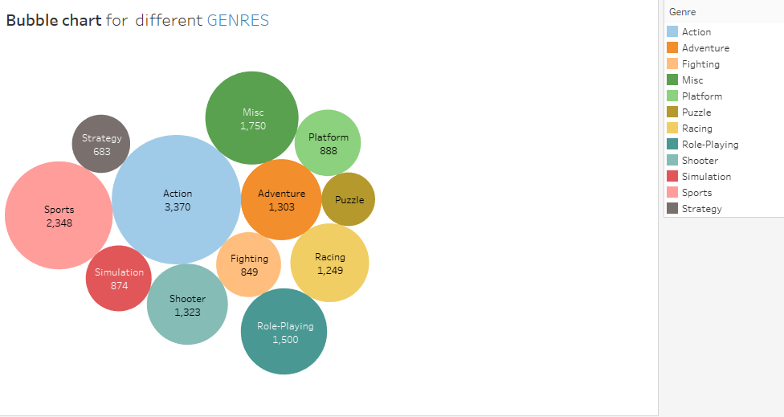

This shows that No. of video games of Action Genre are maximum followed by Sports and rest others.

VISUALIZATION 2:

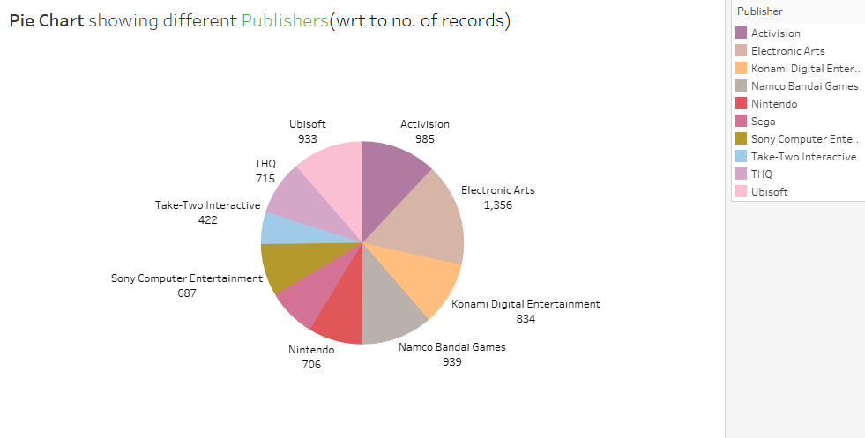

It is a Pie Chart telling that Electronic Arts Publisher have maximum no of games released in the market.

VISUALIZATION 3:

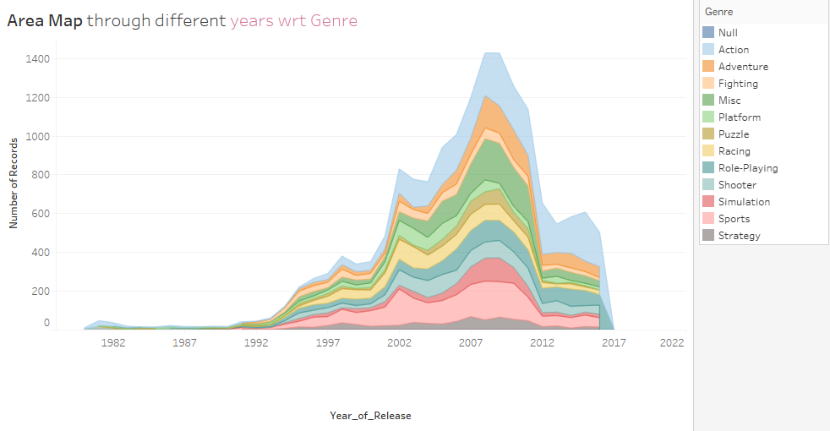

This Area Maps tells that there was gradual increase in the No. of video game being released from the year 1992 with Action and Sports games being preferred more.

VISUALIZATION 4:

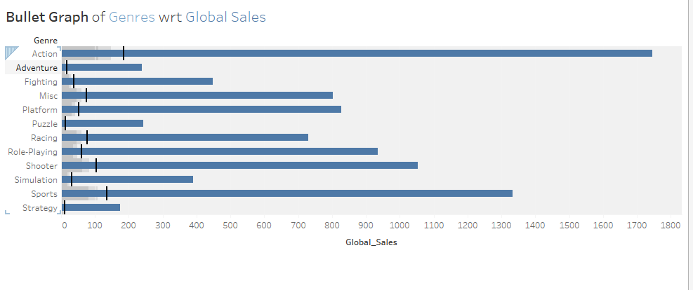

This depicts that the Global sale of Action is more then comes the Sports Game

VISUALIZATION 5:

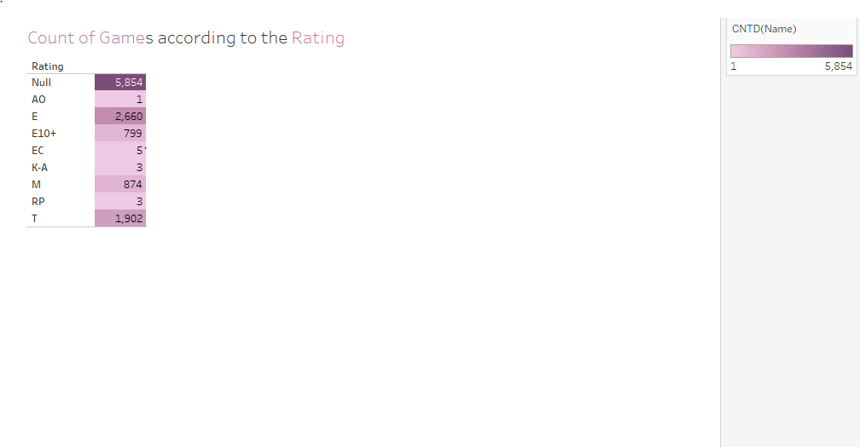

This tell that 5854 games are not rated while Video games with rating E is the most .

VISUALIZATION 6:

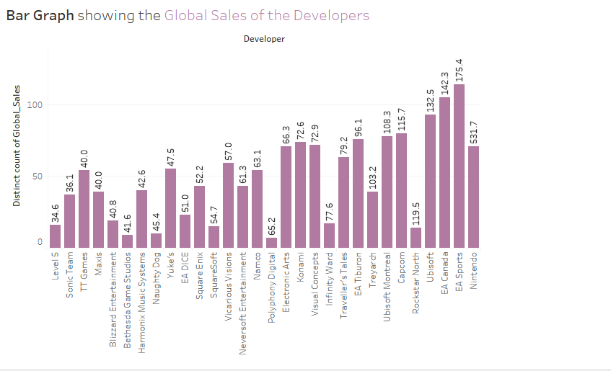

The Global sale of EA Sports developer is maximum.

VISUALIZATION 7:

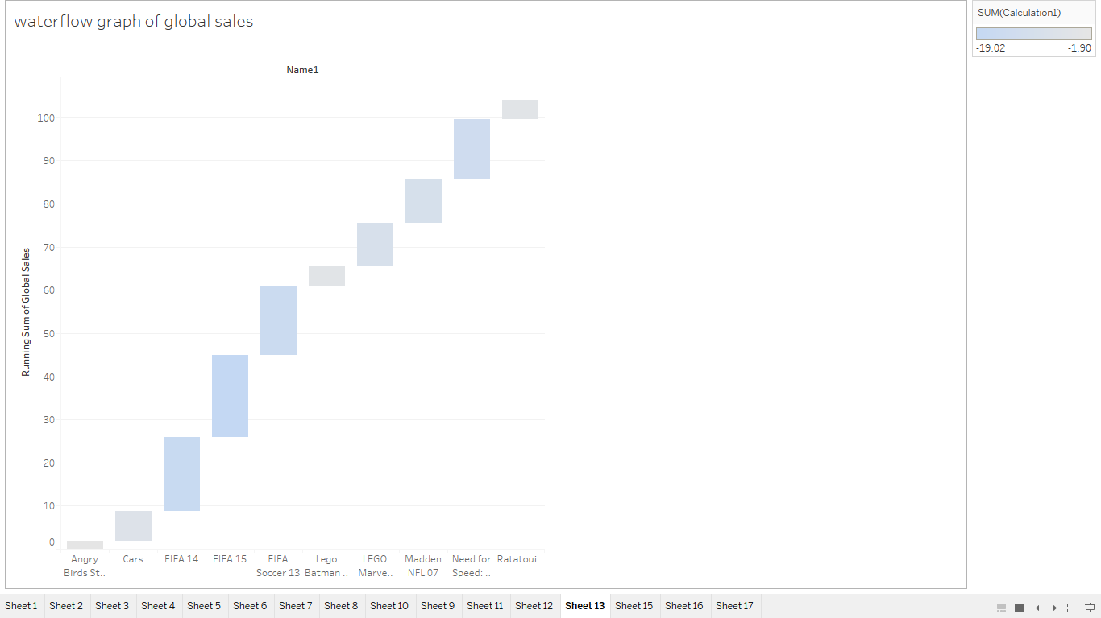

Top 10 games with running total of global sales and we find that FIFA is the most popular game among all of these.

VISUALIZATION 8:

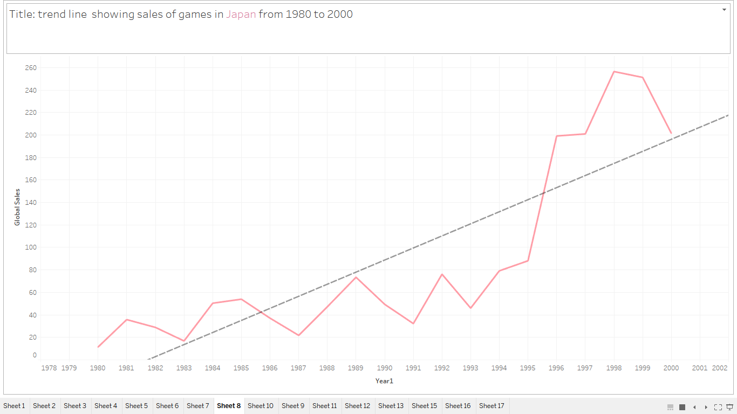

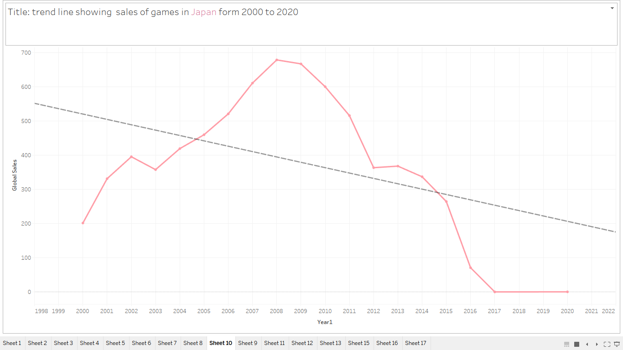

It shows that from 1980 to 2000 the sales of video games in japan is increasing and from 2000 to 2020 it is decreasing this is because of the people are more interested in the mobile now days

VISUALIZATION 9:

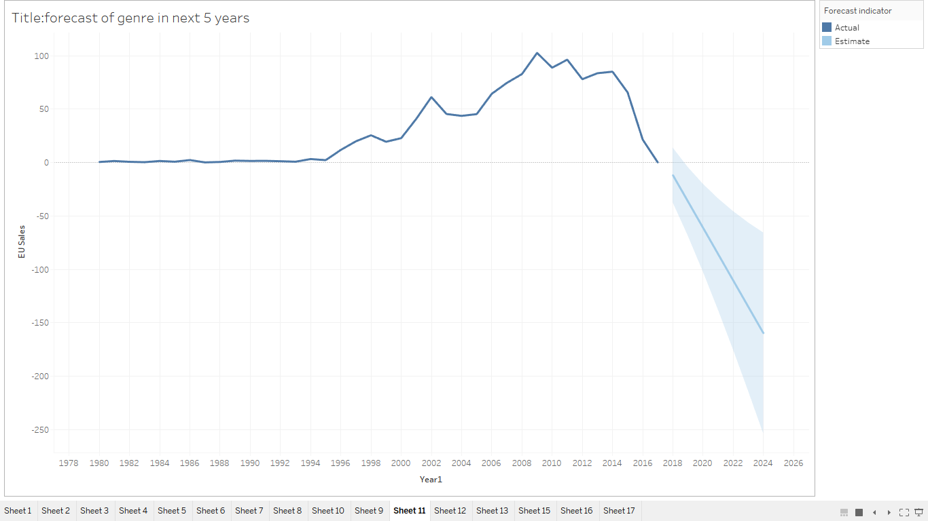

Forecast for next five year

After the decreasing trend the forecast is also decreasing due to many reasons and change of lifestyle of people.

VISUALIZATION 10:

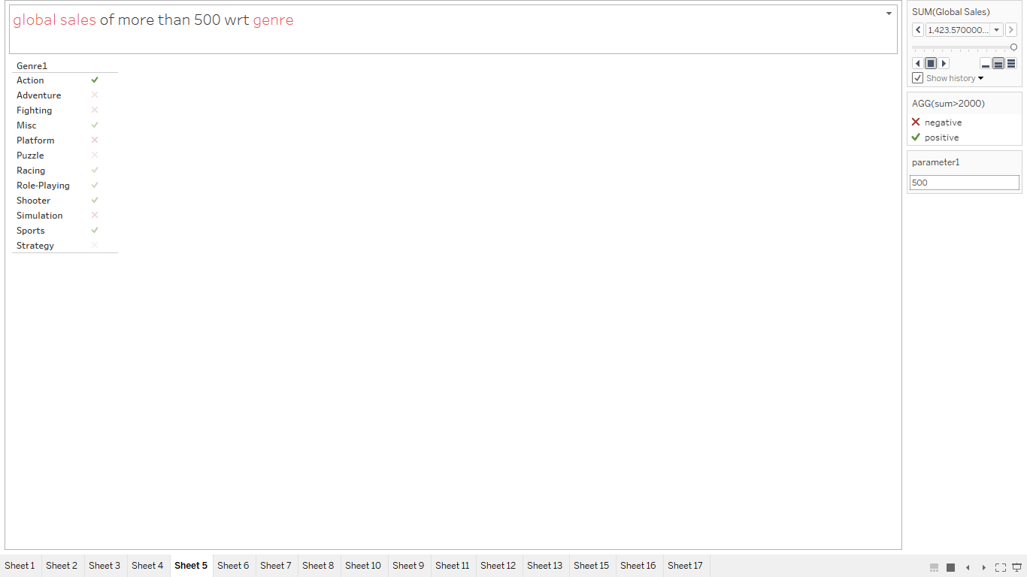

KPI

Positive : Global Sales of the Particular Genre > 500

Negative : Global Sales of the Particular Genre < 500

Sales which are greater than 500 are action , misc , racing,role-playing, shooter, sports they are more likely to be loved by the users

VISUALIZATION 11:

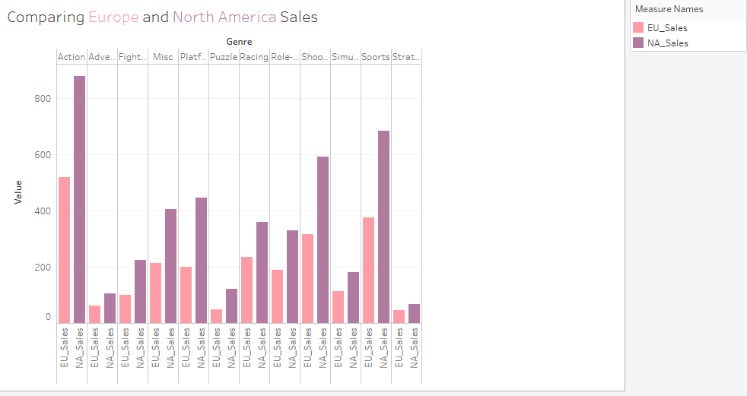

The sale of North America is more as compared to Europe of all the Genre of video games

VISUALIZATION 12:

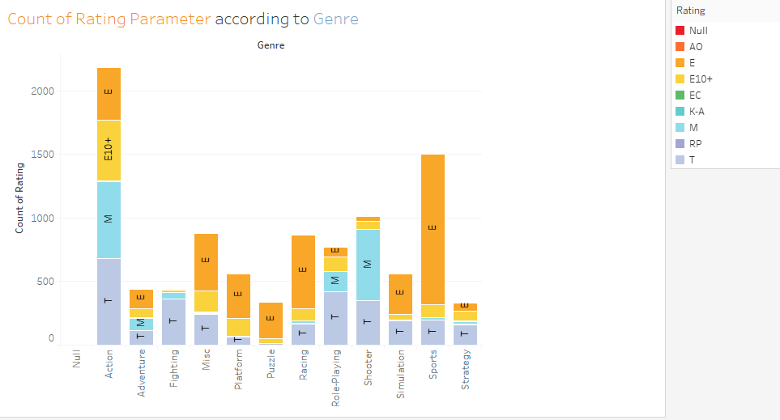

It is found that all Genre games are preferred by everyone.

Sports genre games is liked maximum by the General class ie Everyone.

Mature Class prefer playing Action and Sports games the most.

Contribution of Teens ie 13 and above also play all genre games but Action Games dominates them the most.

VISUALIZATION 13:

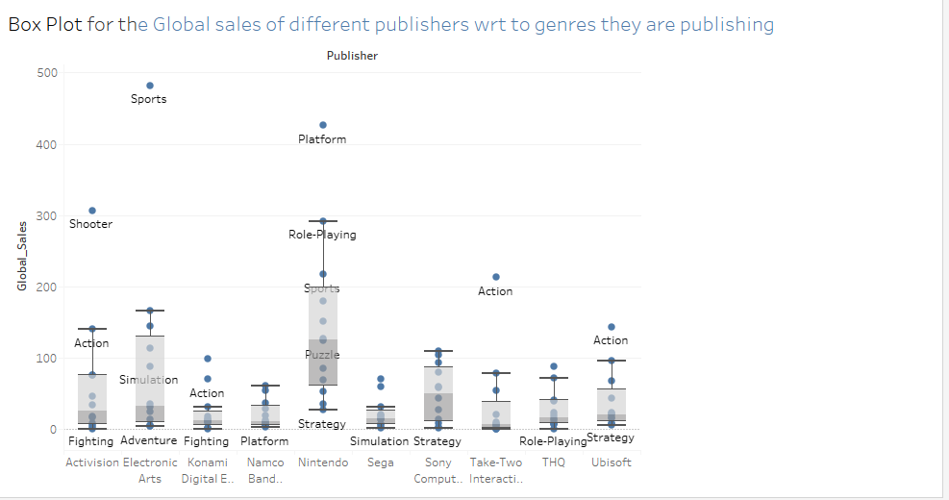

This depicts that Global Sales of Sports Genre is more of publisher Electronic Arts

VISUALIZATION 14:

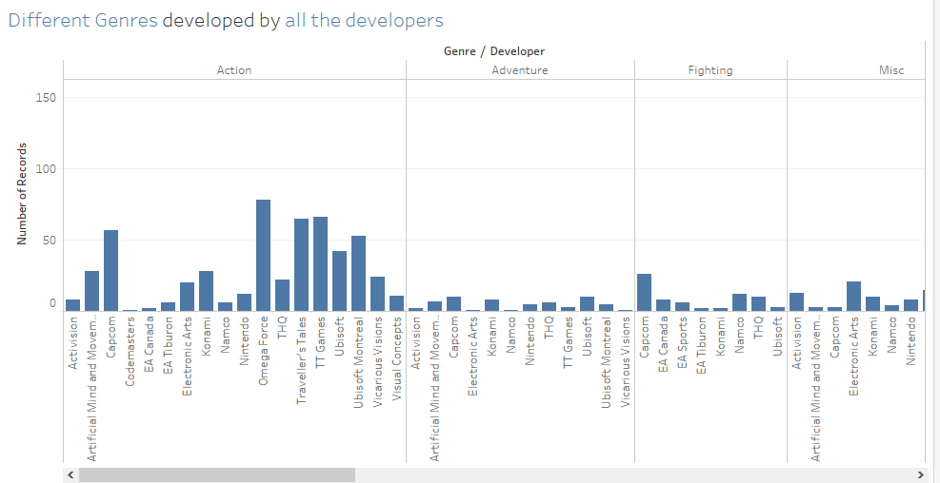

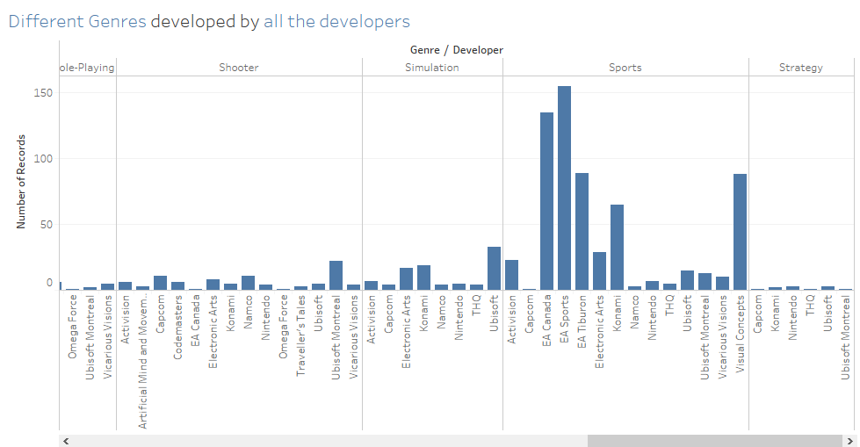

Developers tends to develop more games of Sports and Action Genre .

VISUALIZATION 15:

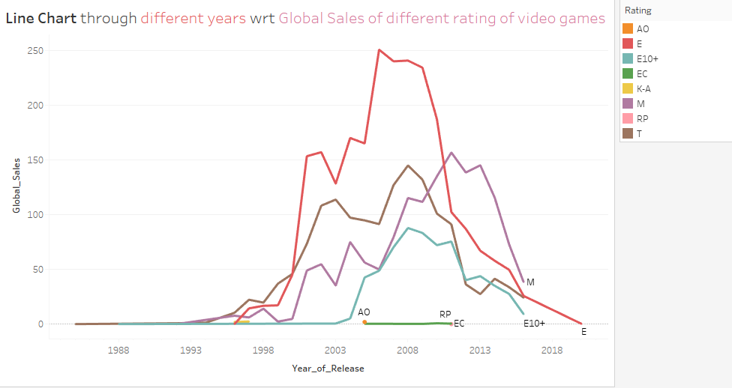

The Global sales of Video Games of various rating has increased over the period of time till there release but the video gamewith rating E has increased the most whereas with rating EC is the same.

VISUALIZATION 16:

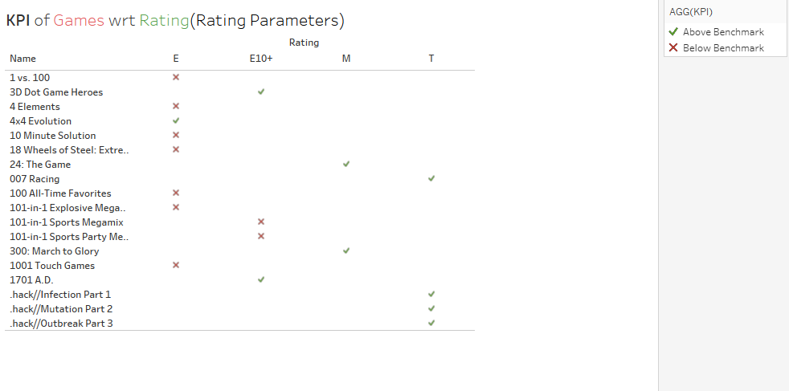

Above BenchMark : Critic Score>50

Below BenchMark : Critic Score<50

Displaying the rating of the Games on the basis of Benchmark.Only 10 games lie above benchmark

VISUALIZATION 17:

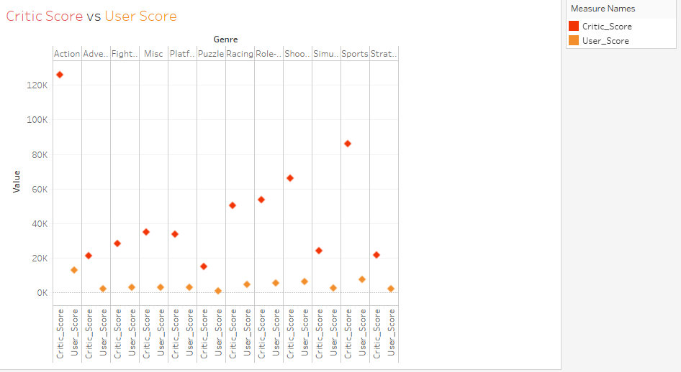

The Critic Score of every Genre(Sports MAX and Puzzle MIN) is more as compared to User Score that is there is difference between critics and users opinion about a Genre of games

VISUALIZATION 18:

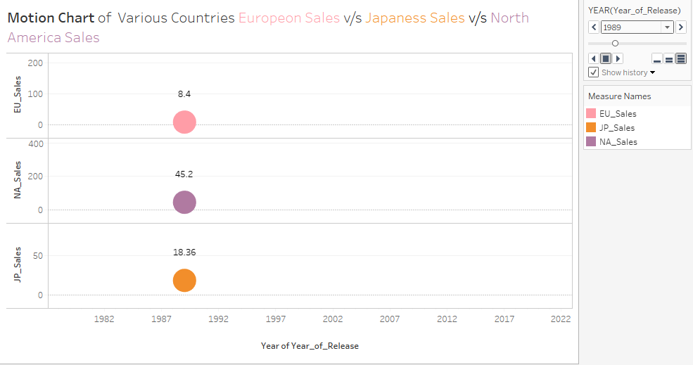

Year 1989(Start) : Maximum Sale-North America

Minimum Sale-Europe

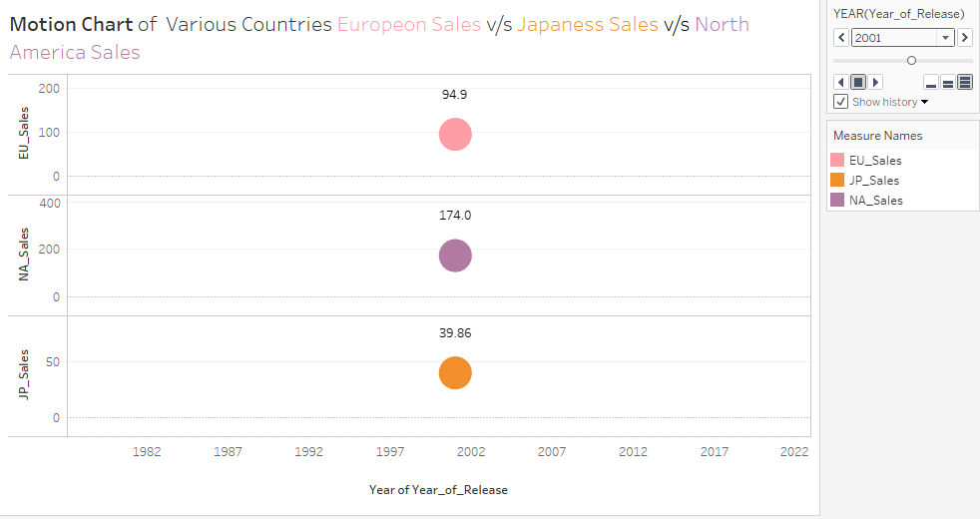

Year 2001(Middle) : Maximum Sale-North America

Minimum Sale-Japan

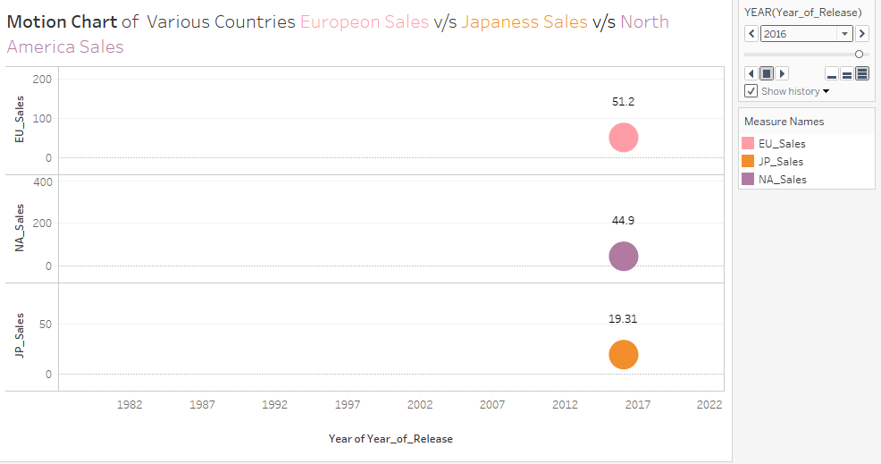

Year 2016(End) : Maximum Sale-Europe

Minimum Sale-Japan

CONCLUSION:

1. Action and Sports games are being preferred the most.
2. Global sales of Action Video game are more
3. Maximum demand of the game was around 2008 as max no of video games were released.
4. Most the Genre of Video Gmeas are liked by all the users of different age groups.
5. North America have the highest market for games.